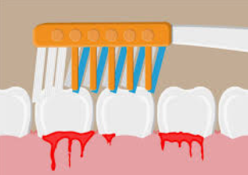 |  | 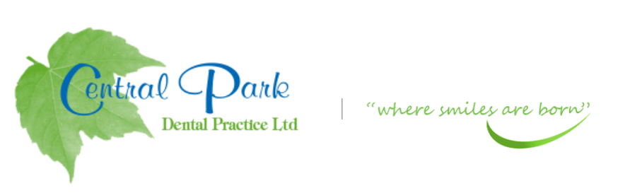  SELF CARE ADVICE FOR YOU AT HOME DURING COVID-19 PANDEMIC
ADVICE OR PRESCRIPTIONS ARE AVAILABLE FROM YOUR DENTIST AT  THIS CURRENT TIME.  Contact  PHONE:  01752 500959  WEBSITE:  Centralparkdentist.co.uk  EMAIL:  cpdental@btconnect.com |  | TEETH THAT HAVE THE FOLLOWING-  BLEEDING GUMS- NO PAIN  - Keep the area clean with gentle brushing in the area with a small headed brush. Do not be afraid if the gums bleed more, the bleeding should improve after a few days.  - Make sure you are brushing your gums as well as your teeth.  - Chlorhexidine mouth wash can help short term. Long term use may stain teeth.  - Do not use mouth wash at the same time as tooth brushing, Use at different times of day.  - Good oral hygiene will help until you can see the dentist.  BLEEDING GUMS – SLIGHT PAIN  - As above instructions.  - Take painkillers if necessary  - Paracetamol and/or Ibuprofen can help settle the pain BUT read the instructions first as TOO MANY WILL NOT IMPROVE THE PAIN but can cause medial problems.  BLEEDING GUMS - EXTREME PAIN  - Contact/Email the practice if pain continues or swelling develops.  TAKE CARE AND STAY SAFE.

