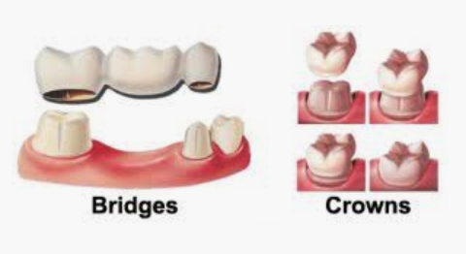 |  | 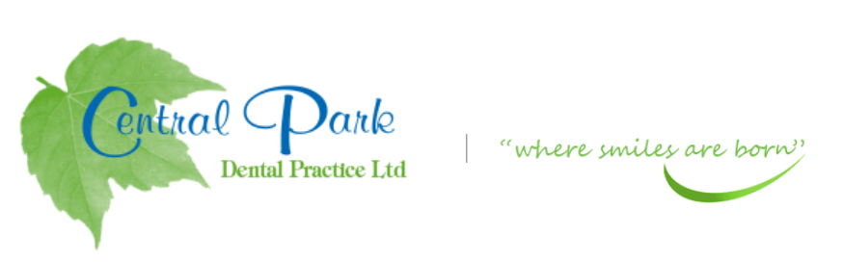  SELF CARE ADVICE FOR YOU AT HOME DURING COVID-19 PANDEMIC
ADVICE OR PRESCRIPTIONS ARE AVAILABLE FROM YOUR DENTIST AT  THIS CURRENT TIME.  Contact  PHONE:  01752 500959  WEBSITE:  Centralparkdentist.co.uk  EMAIL:  cpdental@btconnect.com |  | TEETH THAT HAVE THE FOLLOWING-  BRIDGE OR CROWN THAT HAS COME LOOSE- NO PAIN  - Keep the area clean with gentle brushing in the area.  - Temporary filling cements are available at Pharmacies and  supermarkets.  - Always read the instructions before applying.  - Tooth area needs to be dry or the temporary cement may not bond to the tooth or bridge/crown  - Avoid very hot or cold food/drinks, if possible.  BRIDGE OR CROWN THAT HAS COME LOOSE- SLIGHT PAIN  - As above instructions.  - Take painkillers if necessary  - Paracetamol and/or Ibuprofen can help settle the pain BUT read the instructions first as TOO MANY WILL NOT IMPROVE THE PAIN but can cause medial problems.  BRIDGE OR CROWN THAT HAS COME LOOSE- EXTREME PAIN  - Contact/Email the practice if pain continues or swelling develops.  TAKE CARE AND STAY SAFE.

