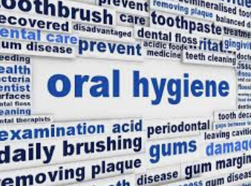 |  | 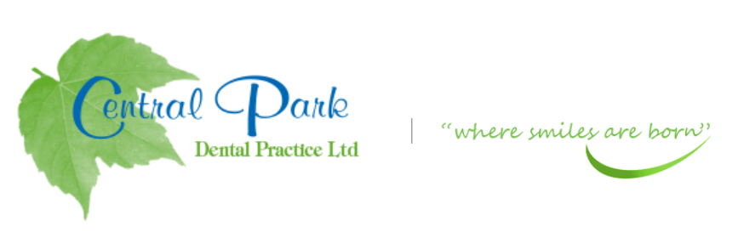  SELF CARE ADVICE FOR YOU AT HOME DURING COVID-19 PANDEMIC
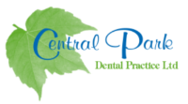  ADVICE OR PRESCRIPTIONS ARE AVAILABLE FROM YOUR DENTIST AT  THIS CURRENT TIME.  CONTACT  PHONE:  01752 500959  WEBSITE:  Centralparkdentist.co.uk  EMAIL:  cpdental@btconnect.com |  | GOOD ORAL HEALTH AT HOME  TOOTH BRUSHING-  - Twice a day for two minutes, with a manual or electric toothbrush.  - Brush the teeth and gums and have the toothbrush bristles at a 45-degree angle.  - Make sure your toothbrush bristles are not flared out, if so, time to buy a new brush or brush head.  - Toothpaste should have the following fluoride amount  - Adult- between 1350 and 1500 PPM  - Children 0-6 years old 1000ppm  - SPIT and DO NOT RINSE after brushing, the longer you leave the toothpaste in your mouth after brushing, the more fluoride protection your teeth are getting.  MOUTHWASH  Use daily.  - DO NOT USE the same time as tooth brushing.  - Parents to advised children on spitting not swallowing of mouth wash.  INTERDENTAL CLEANING-FLOSS OR TEPE’S  - Use daily before or after toothbrushing  - Make sure you have the correct size of tepe  - Online advise is available on all hygiene techniques if you are unsure.  TAKE CARE AND STAY SAFE

